## **Sprint Plan #2 — Kondition (April 23 - May 6)**

### **Goal**

Enable users to sign up and log in securely via Firebase authentication and improve app navigation and interface consistency.

### **User Story 1**

**"As a user, I want to securely create an account so that I may log my workouts."**

* Implement signup flow (3 hours)
* Handle Signup Errors and Feedback (2 hours)
* Look into FastAPI (1 hour)
* Update FastAPI theme to Kondition theme (2 hours)

**Total for user story 1: 8 hours**

**User Story 2**

**“As a returning user, I want to log in so that I can access my personal data.”**

* Test signup and login (1 hour)
* Implement login flow (2 hours)

**Total for user story 2: 3 hours**

**Other Tasks**

* Draw out navigation sequence of wireframes (1 hour)
* Implement wireframe navigation to work with app (3 hours)
* Convert React code to React Native (2 hours)

**Total for other tasks: 6 hours**

## **Team Roles**

* **John Gmuender**: Product Owner, Developer
* **Shayna Das**: Developer
* **Kush Khanna**: Developer
* **Edward Zhou**: Developer
* **Andy Vo**: Scrum Master
* **Akash Srinivasan**: Developer

## **Initial Task Assignment**

* **John Gmuender**: User Story 1 – Implement signup flow; User Story 2 – Test signup and login, Implement login flow
* **Shayna Das**: Other Tasks – Draw out navigation sequence of wireframes
* **Kush Khanna**: User Story 1 – Handle Signup Errors and Feedback, Look into FastAPI, Update FastAPI theme to Kondition theme
* **Edward Zhou**: Other Tasks – Convert React code to React Native
* **Andy Vo**: User Story 2 – Implement login flow; Other Tasks – Draw out navigation sequence of wireframes, Implement wireframe navigation to work with app
* **Akash Srinivasan**: User Story 1 – Implement signup flow

## **Initial Burnup Chart**

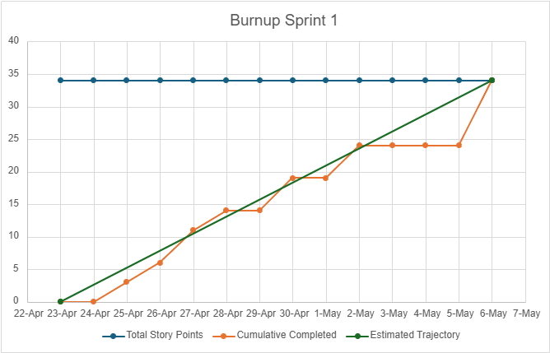

*Sprint 2* Incorrect naming*

## **Initial Scrum Board**

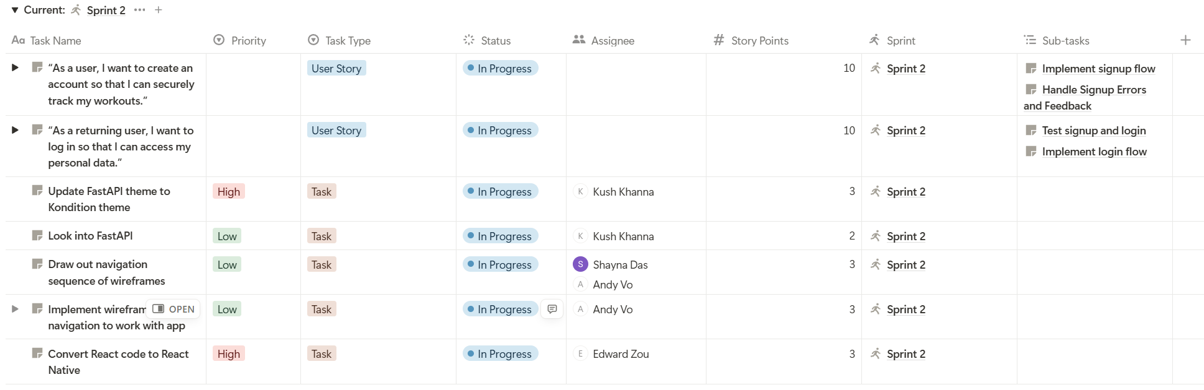

## **Scrum Times**

* Monday, 3:00 PM – 3:15 PM (TA/tutor present)
* Wednesday, 3:00 PM – 3:15 PM
* Friday, 3:00 PM – 3:15 PM